

Child Protection Policy for Academies
2 September 2019 – 1 September 2020

Kingsham Primary School



Contents
Foreword by the Chief Executive Officer and Child Protection Statement
1 | The legal framework within which this policy stands
2 | Definitions
3 | The Policy
 |  | 3.1 | Aims, principles and values
 |  | 3.2 | Leadership and management
 |  | 3.3 | Training
4 | Child Protection Procedure
 |  | 4.1 | Communicating concerns
 |  | 4.2 | Following-up concerns
5 | Confidentiality
6 | Dealing with allegations against staff (including threshold for referral to Local Authority Designated Officer)
7 | Dealing with allegations against pupils including peer-on-peer abuse
 |  | 7.1 | The procedure
 |  | 7.2 | The safeguarding implication of sexual activity between children
 |  | 7.3 | Minimising the risk of peer-on-peer abuse
Annexes
1 | Roles and responsibilities within the academy
2 | Child Protection Flowchart
3 | [Recording concerns sheet – academy specific]
4 | Skin maps
5 | Dealing with disclosures – staff guide
6 | Procedure for DSL receiving concern
7 | Brook sexual behaviours traffic light tool
8 | DSL Procedure for following- up allegation against a child
9 | Resources for briefing visitors, casual, agency and supply staff
9 | Sample briefing sheet for temporary and supply staff
10 | What is child abuse?
11 | Sexting: how to respond to an incident
12 | Female Genital Mutilation (FGM)
13 | Identification – staff and visitor management
14 | Preventing radicalisation
15 | Serious violence
Foreword
“This statement of the University of Chichester Academy Trust’s Child Protection Policy reaffirms the intent of the Trust and its Board to do everything in our power to ensure all the children in our care are protected from harm. It sets out the responsibilities of different people in each academy, but makes clear our philosophy that every adult in our academies is responsible for ensuring our children and young people are safeguarded to the highest standards possible. I ask every one of you to think constantly about how you can improve your day-to-day practice to make sure our children are kept safe from harm. Please give the Policy your total and active support.”
Sue Samson, CEO
The purpose of this policy is to inform staff, parents, volunteers and governors about the school's responsibilities for safeguarding children and to enable everyone to have a clear understanding of how these responsibilities should be carried out. This school takes its responsibility to safeguard children extremely seriously and will train and empower all staff to recognise and respond effectively in order to protect a child who may be at risk of harm. The school will support the development of children in ways that will foster security, confidence and independence and provide an environment in which children feel safe, secure, valued, respected, confident and know how to approach adults if they may be worried. We will develop our curriculum to teach our children how to keep themselves safe. The school will provide a systematic means of monitoring children known or thought to be at risk of harm, and ensure we contribute to assessments of need and support packages for those children. We will ensure good communication between all members of staff and between the school and other agencies. We have and regularly review, a structured procedure within the school which is to be followed by all members of the school community. We have in place other policies which also support safeguarding.
Hilary Faulkner, Headteacher

Child Protection Statement
The University of Chichester Academy Trust Board recognises its moral and statutory responsibility to safeguard and promote the welfare of all children. We make every effort to provide a safe and welcoming environment underpinned by a culture of openness where both children and adults feel secure, able to talk and believe that they are being listened to. We maintain an attitude of “it could happen here” where safeguarding is concerned. The purpose of this policy is to provide staff, volunteers and governors with the framework they need in order to keep children safe and secure in our academies and to inform parents and guardians how we will safeguard their children whilst they are in our care. Specific guidance is available to staff within the procedure documents contained in this policy.
While recognising its own legal responsibilities in the matter of child protection, the Board requires all staff, pupils, parents and visitors to act safely and to co-operate in meeting these obligations. The Board believes that child protection is the responsibility of all adults. It will encourage employees to take an active role in ensuring that the highest standard of child protection is extended to all our pupils.
This policy will be reviewed annually by the Trust and noted by each Local Governing Body in the summer or early autumn terms, but by the end of September each year at the very latest. Local Governing Bodies have a responsibility to ensure the academy-related information in the policy remains current.
In our Trust we will educate and encourage pupils to keep safe through the content of the curriculum and an ethos which helps children to feel safe and able to talk freely about their concerns, secure in the knowledge that they will be listened to and valued.
This Policy must be read alongside HR Policies relating to Safeguarding and Child Protection, specifically the requirement of each Academy to ensure the following procedures are in place:
Employment checks must be carried out in compliance with regulation as outlined in HR Manual.
Temporary and supply staff must be fully briefed about the academy’s safeguarding procedures. A sample briefing document is included in Annex 9.
Visitor Management must follow Trust guidelines as set out in Annex 13. All visitors must me briefed on arrival about what to do if they see or hear anything which concerns them. A ‘script’ for reception staff is included in Annex 9. Visitors whose DBS has not been recorded in the academy’s single central register must be issued with a red lanyard and accompanied at all times. Visitors whose DBS has been recorded in the academy’s single central record must be issued with a green lanyard and are not required to be supervised.
The legal framework within which this policy stands
Academies must have regard to the statutory guidance from the Department for Education issued under Section 175 of the Education Act 2002, the Education (Independent School Standards) Regulations 2014 and the Non-Maintained Special Schools (England) Regulations 2015. This is called Keeping Children Safe in Education. Academies must have regard to it when carrying out their duties to safeguard and promote the welfare of children. This means that you should comply with it unless exceptional circumstances arise.
Local Authorities under Section 10 of the Children Act 2004 have a responsibility to promote inter-agency co-operation to improve the welfare of children. This guidance is called Working Together to Safeguard Children and applies, in its entirety, to all schools and should be complied with unless exceptional circumstances arise.
This policy is based on the 2016/2019 Keeping Children Safe in Education (KCSiE) and Working Together to Safeguard Children (2015/2018) and signposts the relevant procedures set out by the Local Safeguarding Children Partnership which are referenced in this policy. The policy also references Disqualification under the Childcare Act 2006 (2015), Female Genital Mutilation Act 2003 Mandatory Reporting Guidance (2016) and statutory Guidance on the Prevent duty under the Counter-Terrorism and Security Act 2015. This policy will be reviewed as and when updates to statutory guidance are published. Any changes will be communicated to each academy through an update to this policy.
There are sections of this policy which invite individual academies to add information relevant to their specific context. This should be undertaken through review processes involving academy staff and agreed by the Local Governing Body. Each Academy may have a broader Safeguarding Policy which must not supersede policy or guidance outlined in this policy, but may add material.
Local Safeguarding Children Partnership protocols and guidance can be found using these links:
Hampshire safeguarding children Partnership protocols and guidance
Portsmouth safeguarding children Partnership protocols and guidance
West Sussex safeguarding children partnership protocols and guidance

2. Definitions
Child Protection is an aspect of safeguarding, but is focused on how we respond to children who have been significantly harmed or are at risk of significant harm.
The term Staff applies to all those working for or on behalf of the academy, full time or part time, in either a paid or voluntary capacity. This also includes parents and governors.
Child refers to all young people who have not yet reached their 18 birthday. On the whole, this will apply to pupils of our academy; however the policy will extend to visiting children and students from other establishments
Parent refers to birth parents and other adults in a parenting role for example adoptive parents, step parents, guardians and foster carers.
Abuse could mean neglect, physical, emotional or sexual abuse or any combination of these. Parents, carers and other people can harm children either by direct acts and / or failure to provide proper care.
A full outline of types of abuse can be found in Annex 10.
3. The Policy
3.1 Aims, principles and values
- To provide staff with the framework to promote and safeguard the wellbeing of children and in so doing ensure they meet their statutory responsibilities.
- To ensure consistent good practice across the Trust and its academies.
- To demonstrate our commitment to protecting children.
Principles and Values
- Children have a right to feel secure and cannot learn effectively unless they do so.
- All children regardless of age, gender including trans gender, race, disability, sexuality, religion and non-religion, culture or language have a right to be protected from harm.
- All staff have a key role in prevention of harm and an equal responsibility to act on any suspicion or disclosure that may indicate a child is at risk of harm, either in the academy or in the community.
- We acknowledge that working in partnership with other agencies protects children and reduces risk and so we will engage in partnership working throughout the child protection process to safeguard children.
- Whilst the Trust and its academies will work openly with parents as far as possible, we have the responsibility and the right to contact children’s social care or the police, without notifying parents if this is believed to be in the child’s best interests.

3.2 Leadership and management
We recognise that staff anxiety around child protection can undermine good practice and so have established clear lines of accountability, training and advice to support the process and individual staff within that process.
In this academy any individual can contact the designated safeguarding lead (DSL) if they have concerns about a young person. There is a nominated safeguarding governor, who will take leadership responsibility for safeguarding. The Chief Executive Officer or the Trust Safeguarding Lead will receive reports of allegations against the headteacher and act on the behalf of the governing body.
In this academy roles are allocated as follows:
Role | Name | Contact
Designated Safeguarding Lead: | Hilary Faulkner, HT | 01243 784046  office@kingshamprimary.org.uk
Deputy Designated Safeguarding Lead(s): | Victoria Leslie AHT  Rachel Pallett AHT  Rachel Towle AHT  Ian Williams SENCo | 01243 784046  office@kingshamprimary.org.uk
Safeguarding Governor | Carol Hughes | 01243 784046  office@kingshamprimary.org.uk
The Chief Executive Officer | Sue Samson | 01243 816444  s.samson@chi.ac.uk
Trust Safeguarding Lead | James Humphries | 01243 816444  j.humphries@chi.ac.uk

Detailed descriptions of the roles and responsibilities of leadership in the academy are set out in Annex 1.
As an employer we comply with the Childcare (Disqualification) regulations 2009 under the childcare act 2006 guidance issued in February 2015. Trust guidance can be found in the Trust HR Manual Policies and Procedures “Staff Disclosure of Disqualification”.

3.3 Training
All staff in our academies are expected to be aware of the signs and symptoms of abuse and must be able to respond appropriately.
As a minimum, the Trust expects academies to provide:
- annual training in the form of a briefing for all staff, every year;
- the same training as part of induction for staff joining an academy;
- relevant training to ensure staff appointed to specific roles can undertake that role effectively and
- timely updates to all relevant staff on changes to local or national policy or practice.
In this academy our staff are trained through the following provision:
- annual update training and a review of the policy for all staff at the beginning of the academic year
- safeguarding training is included in induction training for all staff when they join Kingsham Primary School
- annual training for the governing board
- training every two years for the designated safeguarding lead and deputy leads
- Regular attendance at designated safeguarding lead events run by the local authority and the Trust
- Training for staff to enable them to undertake safeguarding aspects of their roles, for example Holistix training for the Learning mentor
- Regular updates and reminders at weekly staff briefing
4. Child Protection Procedure
The following procedures apply to all staff working in the Trust and will be covered by training to enable staff to understand their role and responsibility.
The prime concern at all stages must be the interests and safety of the child. Where there is a conflict of interest between the child and an adult, the interests of the child must be paramount.
Staff are alert to signs of abuse, neglect, including physical, sexual and emotional abuse, peer-on-peer abuse, being at risk from or involvement in serious violence and female genital mutilation. They must follow the appropriate procedure set out in this policy and its annexes
All staff are aware that children with disabilities, special needs or with language delay may communicate concerns with behaviours rather than words. Additionally staff will question the cause of knocks and bumps in children who have limited mobility.
Consideration should be given to the context within which behaviours and/or incidents occur. Assessments of children should consider whether wider environmental factors are present in a child’s life that are a threat to their safety and/or welfare. This is ‘contextual safeguarding’.
The flowchart in Annex 2 summarises this procedure.
4.1 Communicating concerns
The aim of our procedures is to provide a robust framework which enables staff to take appropriate action when they are worried a child is being abused or at risk of harm. The annexes of this policy aim to provide staff with the tools they require to follow the processes and information about forms of abuse to which they must be alert.
This procedure is to be used If a member of staff
- suspects abuse, spots signs or indicators of abuse;
- is concerned that a child is being radicalised and at risk of being drawn into terrorism;
- has a disclosure of abuse made to them or
- suspects a child might be at risk from or is involved in serious violent crime.
This procedure is not to be used if a member of staff discovers an act of female genital mutilation appears to have been carried out, the member of staff must report this to the police with support from the DSL (see Annex 12).
- Make an initial record of the information on the yellow form - Annex 3
- Report it to the DSL or Deputy DSL / headteacher immediately
- The DSL or headteacher will consider if there is a requirement for immediate medical intervention, however urgent medical attention should not be delayed if DSL or headteacher are not immediately available (see 4.2 below)
- Make an accurate record (which may be used in any subsequent court proceedings) as soon as possible and within 24 hours of the occurrence, of all that has happened, including details of:
- Dates and times of their observations
- Dates and times of any discussions they were involved in.
- Any injuries (use skin maps in Annex 4)
- Explanations given by the child / adult
- What action was taken
- Any actual words or phrases used by the child
The records must be signed and dated by the author or / equivalent on electronic based records and handed to the Headteacher or is she is unavailable, to one of the Deputy Designated Safeguarding Leads.

4.2 Following-up concerns
Following any concerns raised by staff, the DSL will assess the information and consider if significant harm has happened or there is a risk that it may happen. If the evidence suggests the threshold of significant harm, or risk of significant harm has been reached; or they are not clear if the threshold is met, then the DSL will contact children’s social care through the relevant procedure or the police if appropriate. If the DSL is not available or there are immediate concerns, the staff member will refer directly to children’s social care. Remember that anyone can make referals to the Multi Agency Safeguarding Hub if they consider a child is at immediate or significant harm and the DSL is not available.
Contact for MASH:
Portsmouth: 0845 671 0271
Hampshire: 0300 555 1384
West Sussex: 01403 229900 (0330 222 6664 out of office hours)

Generally the DSL will inform the parents prior to making a referral however there are situations where this may not be possible or appropriate particularly when informing parents/carers may place the child at further risk.
N.B. The exception to this process will be in those cases of known FGM where there is a mandatory requirement for the teacher to report directly to the police, although the DSL should also be made aware.
Detailed guidance for responding to disclosures is contained in Annex 5
Detailed guidance for DSLs in how to follow-up a concern is contained Annex 6

5. Confidentiality
- We maintain that all matters relating to child protection are to be treated as confidential and only shared as per the ‘working together’ guidance.
- There is a lawful basis for child protection concerns to be shared with agencies who have a statutory duty for child protection.
- Information is to be shared with individuals within the Trust who ‘need to know’.
- All staff are aware that they cannot promise a child to keep a disclosure confidential.

6. Dealing with allegations against staff
This procedure should be used in all cases in which it is alleged a member of staff or volunteer in a school, or another adult who works with children has:
- behaved in a way that has harmed a child, or may have harmed a child;
- possibly committed a criminal offence against or related to a child; or
- behaved towards a child or children in a way that indicates he or she would pose a risk of harm to children
In dealing with allegations or concerns against an adult, staff must:
- Report any concerns about the conduct of any member of staff or volunteer to the Headteacher or the DSL as soon as possible
- If an allegation is made against the Headteacher, the concerns need to be raised with the CEO of the Trust or the Trust Safeguarding Lead as soon as possible
- There may be situation when the Headteacher or Trust central staff will want to involve the police immediately if the person is deemed to be an immediate risk to children or there is evidence of a possible criminal offence.
- Once an allegation has been received by the Headteacher or Central Trust they will, if the threshold is met, contact the Local Authority Designated Officer
  - Trust Central Team: 01243 793500
  - Portsmouth LADO: 02392 882500
  - Hampshire LADO:01962 876364
  - West Sussex LADO: 0330 222 3339
as soon as possible and before carrying out any investigation into the allegation other than preliminary enquiries.
- Inform Central HR at the Trust
- Inform the parents of the allegation unless there is a good reason not to
In liaison with the LADO, the school will determine how to proceed and if necessary the LADO will refer the matter to children’s social care and/or the police.
The Trust has a Public Interest Disclosure (whistleblowing) policy which should be referred to if appropriate.
If the allegation is against the headteacher, the person receiving the allegation will contact the Trust CEO directly.

7. Dealing with allegations against pupils including peer-on-peer abuse
The Trust believes that all children have a right to attend school and learn in a safe environment. We recognise that children are capable of abusing their peers. In most instances, the conduct of pupils towards each other will be covered by the behaviour policy. Some allegations may be of such a serious nature that they may raise safeguarding concerns and these will be dealt with under this policy and in line with Keeping Children Safe in Education (2019). These allegations are most likely to include physical abuse, emotional abuse, sexual abuse and sexual exploitation. It is also likely that incidents dealt with under this policy will involve older students and their behaviour towards younger students or those who are vulnerable. If one or more of these factors is alleged, then it is to be dealt with using this procedure:
The allegation:
    - is made against an older pupil and refers to their behaviour towards a younger pupil or a more vulnerable pupils
    - is of a serious nature, possibly including a criminal offence;
    - raises risk factors for other pupils in the school;
    - indicates that other pupils may have been affected by this student and/or
    - indicates that young people outside the school may be affected by this student.
Examples of safeguarding issues against a student could include but are not limited to:
Bullying (including cyberbullying)
Physical Abuse
- Violence, particularly pre-planned
- Forcing others to use drugs or alcohol
Emotional Abuse
- Blackmail or extortion
- Threats and intimidation
Sexual Abuse
- Indecent exposure, indecent touching or serious sexual assaults
- Forcing others to watch pornography or take part in sexting (specific advice about how to approach incidents of sexting is contained in Annex 11)
- other behaviours outlined in the Brook traffic light tool (Annex 6)
Sexual Exploitation
- Encouraging other children to engage in inappropriate sexual behaviour ( For example - having an older boyfriend/girlfriend, associating with unknown adults or other sexually exploited children, staying out overnight)
- Photographing or videoing other children performing indecent acts
Sexual violence
- Rape
- Assault by penetration and sexual assault
Sexual harassment
- Sexual comments, remarks, jokes
- Online sexual harassment which may be stand alone or part of a broader pattern of abuse
Upskirting
- Taking a picture under a person’s clothing without them knowing, with the intention of viewing their genitals or buttocks to obtain sexual gratification or cause the victim humiliation, distress or alarm
Sexting – youth produced sexual imagery
Initiation/hazing type violence and rituals

7.1 The procedure
When an allegation is made by a pupil against another student, members of staff should consider whether the complaint raises a safeguarding concern. If there is a safeguarding concern a factual record of the allegation should be made, but no attempt at this stage should be made to investigate the circumstances. The designated safeguarding lead (DSL) should be informed and the procedure in Annex 8 should be followed.
7. 2 The safeguarding implications of sexual activity between children
The intervention of child protection agencies in situations involving sexual activity between children can require difficult professional judgments. Some situations are statutorily clear – for example, a child under the age of 13 cannot consent to sexual activity. But it will not necessarily be appropriate to initiate safeguarding procedures where sexual activity involving children and young people below the age of legal consent (16 years) comes to notice. In our society generally the age at which children become sexually active has steadily dropped. It is important to distinguish between consensual sexual activity between children of a similar age (where at least one is below the age of consent), and sexual activity involving a power imbalance, or some form of coercion or exploitation. It may also be difficult to be sure that what has or has been alleged to have taken place definitely does have a sexual component.
As usual, important decisions should be made on a case by case basis, on the basis of an assessment of the children’s best interests. Referral under safeguarding arrangements may be necessary, guided by an assessment of the extent to which a child is suffering, or is likely to suffer, significant harm. Key specific considerations will include:
- The age, maturity and understanding of the children;
- Any disability or special needs of the children;
- Their social and family circumstance;
- Any evidence in the behaviour or presentation of the children that might suggest they have been harmed;
- Any evidence of pressure to engage in sexual activity;
- Any indication of sexual exploitation;
There are also contextual factors. Gender, sexuality, race and levels of sexual knowledge can all be used to exert power. A perpetrator of sexual abuse may sometimes be a woman or girl and the victim a boy. The Brook traffic light tool (Annex 7) can be useful in making these considerations.
7.3 Minimising the risk of peer on peer abuse
We will minimise the risk of peer-on-peer abuse by:
- taking a whole school approach to safeguarding and child protection
- providing training for staff;
- providing a clear set of values and standards, underpinned by the academy’s behaviour policy and pastoral support system and by planned programme of evidence-based content delivered through the curriculum and
- engaging with specialist support and interventions.

Annual review
As a Trust, we review this policy at least annually in line with DfE, Local Safeguarding Children Boards/Partnerships for Hampshire, Portsmouth and West Sussex and other relevant statutory guidance.

Last Review | 22 July 2019
Department/Owner | Trust Board  Local Governing Body
Review Date | 30 August 2020

Annex 1
Roles and responsibilities within Academy

Staff responsibilities
All staff have a key role to play in identifying concerns early and in providing help for children. To achieve this they will:
- Establish and maintain an environment where children feel secure, are encouraged to talk and are listened to.
- Ensure children know that there are adults in the academy whom they can approach if they are worried about any problems.
- Plan opportunities within the curriculum for children to develop the skills they need to assess and manage risk appropriately and keep themselves safe.
- Attend training in order to be aware of and alert to the signs of abuse.
- Maintain an attitude of “it could happen here” with regards to safeguarding.
- Record their concerns if they are worried that a child is being abused and report these to the relevant person as soon as practical that day.
- Be prepared to refer directly to social care, and the police if appropriate, if there is a risk of significant harm and the DSL or their Deputy is not available.

- If the disclosure is an allegation against a member of staff they report this to the DSL or if the allegation is against the DSL or Headteacher, to the Central Trust.
- Follow the procedures set out by the Portsmouth/Hampshire/West Sussex Local Safeguarding Children Partnership and take account of guidance issued by the DfE.
- Support pupils in line with their child protection plan.
- Treat information with confidentiality but never promising to “keep a secret”.
- Notify DSL of any child on a child protection plan who has unexplained absence.
- Have an understanding of early help and be prepared to notify colleagues and/or parents of any concerns about their child(ren), and provide them with, or signpost them to, opportunities to change the situation.
- Liaise with other agencies that support pupils and provide early help.
- Ensure they know who the designated safeguarding lead (DSL) and deputy DSL are and know how to contact them.
- Have an awareness of this Child Protection Policy, the Behaviour Policy, the staff Code of Conduct procedures relating to the safeguarding response for children who go missing from education and the role of the DSL.

Senior leadership team responsibilities:
- Contribute to inter-agency working in line with guidance (working together 2018)
- Provide a co-ordinated offer of early help when additional needs of children are identified
- Ensure staff are alert to the various factors that can increase the need for early help.
- Working with children’s social care, support their assessment and planning processes including the schools attendance at conference and core group meetings
- Carry out tasks delegated by the Trust or the local governing body such as training of staff; safer recruitment; maintaining a single central register an complying with the visitor management procedure of issuing green and red lanyards
- Complete a Section 11 Compact Audit and submit to the Trust by the end of the first half of the Autumn term each year with the associated action plan. Hampshire schools must submit to their LCSB annually, Portsmouth every two years. There is no requirement for West Sussex Schools to submit an audit to their LCSB, so our West Sussex academies may choose to complete the HCC Word template or the PCC Excel template.
- Hampshire audit tool (word)
- Portsmouth audit tool (excel) – ‘self-assessment audit’ at bottom of page
- Provide support and advice on all matters pertaining to safeguarding and child protection to all staff regardless of their position within the academy.
- Treat any information shared by staff or pupils with respect and follow Portsmouth/Hampshire/West Sussex Local Safeguarding Children Partnership procedures.
- Ensure that allegations or concerns against staff are dealt with in accordance with guidance from department for education (DfE) in accordance with Trust policy and procedures.

Trust/Governing body responsibilities
- The academy has effective safeguarding policies & procedures including this child protection policy the staff code of conduct, a Behaviour Policy and a response to children who go missing from education.
- The academy undertakes a Section 11 Compact Audit as outlined above, is shared with the LGB and submitted to the Trust as outlined above.
- Recruitment, selection and induction follows Trust processes including safer recruitment practice and all appropriate checks.
- Allegations against staff are dealt with by the headteacher. Allegations against the headteacher are dealt with by the Trust CEO.
- A member of the senior staff team is designated as designated safeguarding lead (DSL) and have this recorded in their job profile.
- The DSL must work within the requirements as detailed in Annex B of Keeping Children Safe in Education.
- Staff have been trained appropriately and this is updated in line with guidance
- Any safeguarding deficiencies or weaknesses are remedied without delay
- They have identified a nominated governor for leading safeguarding

DSL responsibilities (to be read in conjunction with DSL role description in KCSiE)
In this school the DSL is Hilary Faulkner (Headteacher)
The deputy DSL are name(s) Victoria Leslie (AHT), Rachel Pallett (AHT), Rachel Towle (AHT) and Ian Williams (SENCO)

In addition to the role of staff and senior management team the DSL will

- Refer cases to social care and the police where appropriate, in a timely manner avoiding any delay that could place the child at more risk.
- Assist the Trust and the governing body in fulfilling their responsibilities
- Attend initial training for the role and refresh this every other year. By attending appropriate training and demonstrating evidence of continuing professional development thereafter
- Ensure every member of staff knows who the DSL is, is aware of the DSL role and has their contact details
- Ensure all staff and volunteers understand their responsibilities in being alert to the signs of abuse and responsibility for referring any concerns to the DSL
- Ensure that whole academy training occurs regularly with at least annual updates so that staff and volunteers can fulfil their responsibilities
- Ensure any members of staff joining the academy outside of this training schedule receive induction prior to commencement of their duties
- Keep records of child protection concerns securely and separately from the main pupil file and use these records to assess the likelihood of risk
- Ensure that safeguarding records are transferred accordingly (separate from pupil files) when a child transfers school
- Ensure that where a pupil transfers school and is on a child protection plan or is a child looked after, the information is passed to the new school immediately and that the child’s social worker is informed
- Link with the LSCB to make sure staff are aware of training opportunities and the latest local policies on safeguarding
- Develop, implement and review procedures in our school that enable the identification and reporting of all cases, or suspected cases, of abuse
- Meet any other expectations set out for DSLs in Keeping Children Safe in Education 2019.

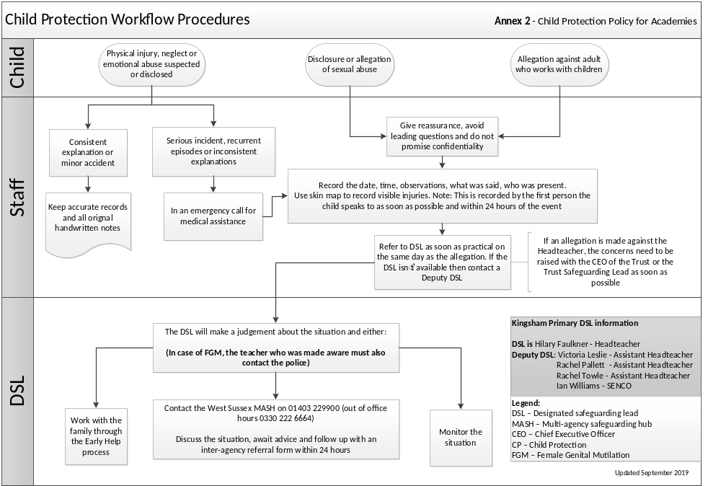
Annex 3
Safeguarding Record of Concerns / Disclosure
Child's name: | Child's date of birth:
Name and role of person raising concern: | Date:  Time:

Details of concern:
(Where? When? What? Who? Behaviours? Use child’s words)

Continue on a separate sheet as necessary.
Your signature:
Record passed to the Designated Manager for Safeguarding (DMS) at Kingsham Primary School: |  |  | (Please tick) |  | Date:
Actions taken
Date | Person taking action | Action taken |  | Outcome of action

Name: Designation:
Copied to:

Child's name: | Child's date of birth:
Name and role of person raising concern: | Date:
Continuation Sheet

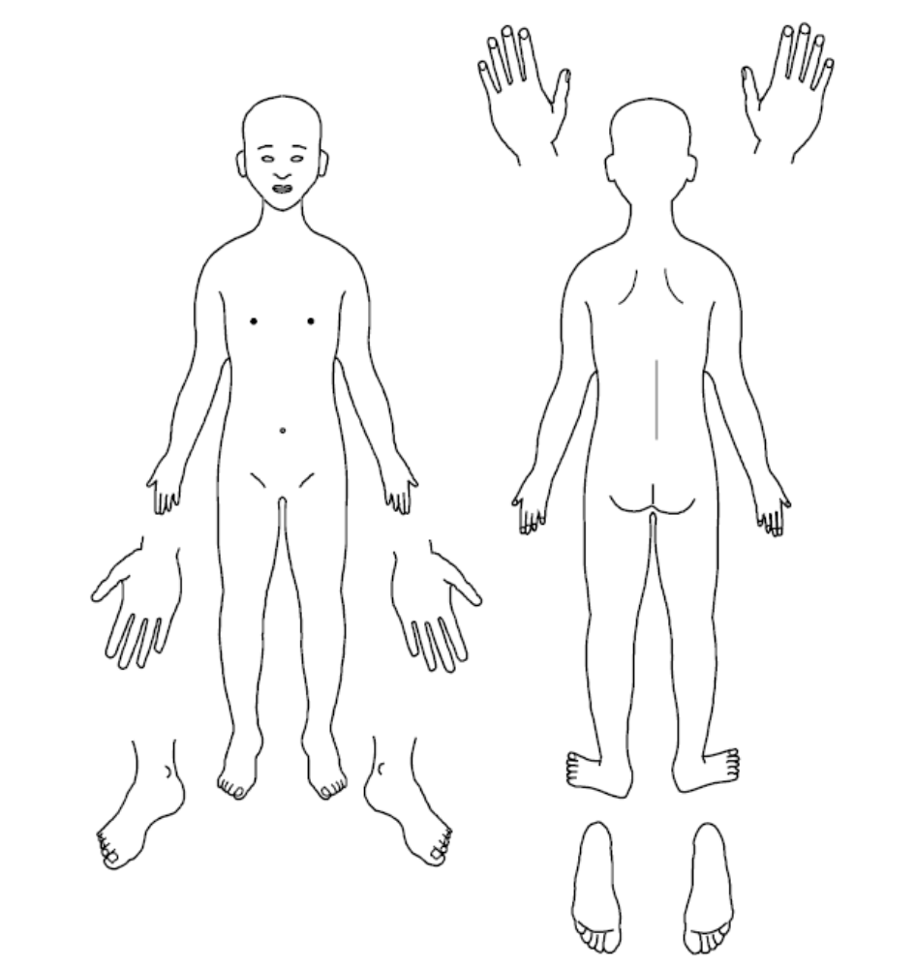
Skin Map Annex 4Error! Bookmark not defined.

Name of Child: _______________________________________________________

Date of birth: _________________________ Date of recording: _________________

Name of completer: ____________________________________________________

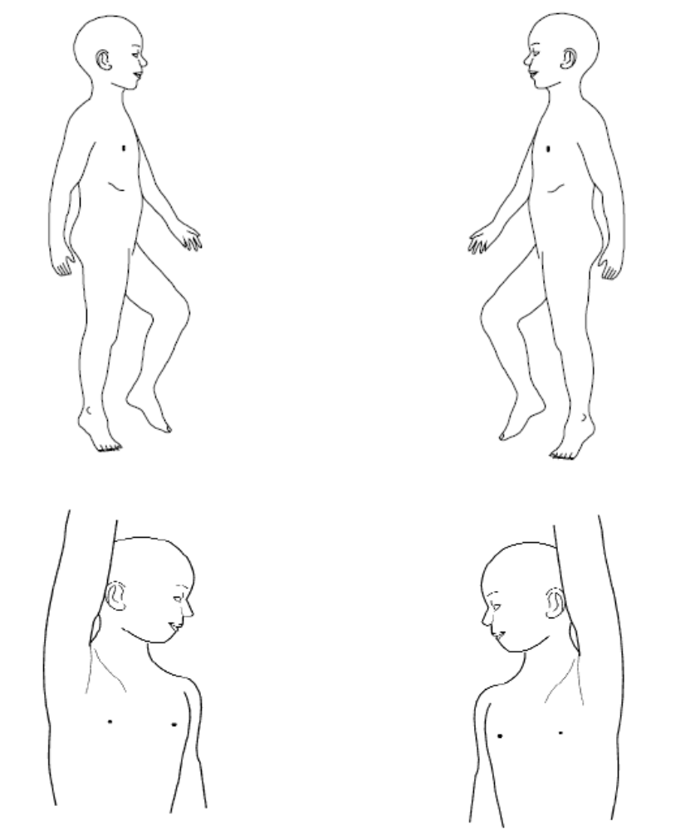
Any additional information:

Annex 5
Dealing with disclosures

All staff should:
A member of staff who is approached by a child should listen positively and try to reassure them. They cannot promise complete confidentiality and should explain that they may need to pass information to other professionals to help keep the child or other children safe. The degree of confidentiality should always be governed by the need to protect the child.
Additional consideration needs to be given to children with communication difficulties and for those whose preferred language is not English. It is important to communicate with them in a way that is appropriate to their age, understanding and preference.
All staff should know who the DSL is and who to approach if the DSL is unavailable. Ultimately, all staff have the right to make a referral to the police or social care directly and should do this if, for whatever reason, there are difficulties following the agreed protocol, e.g. they are the only adult on the school premises at the time and have concerns about sending a child home.
Guiding principles, the seven R’s
Receive
- Listen to what is being said, without displaying shock or disbelief
- Accept what is said and take it seriously
- Make a note of what has been said as soon as practicable

Reassure
- Reassure the pupil, but only so far as is honest and reliable
- Don’t make promises you may not be able to keep e.g. ‘I’ll stay
with you’ or ‘everything will be alright now’ or ‘I’ll keep this confidential’
- Do reassure e.g. you could say: ‘I believe you’, ‘I am glad you came to me’, ‘I am sorry this has happened’, ‘We are going to do something together to get help’

Respond
- Respond to the pupil only as far as is necessary for you to establish whether or not you need to refer this matter, but do not interrogate for full details
- Do not ask ‘leading’ questions i.e. ‘did he touch your private parts?’ or ‘did she hurt you?’ Such questions may invalidate your evidence (and the child’s) in any later prosecution in court
- Do not ask the child why something has happened.
- Do not criticise the alleged perpetrator; the pupil may care about him/her, and reconciliation may be possible
- Do not ask the pupil to repeat it all for another member of staff. Explain what you have to do next and whom you have to talk to. Reassure the pupil that it will be a senior member of staff

Report
- Share concerns with the designated safeguarding lead as soon as possible
- If you are not able to contact your designated safeguarding lead, and the child is at risk of immediate harm, contact the children’s services department directly
- If you are dissatisfied with the level of response you receive following your concerns, you should press for re-consideration

Record
- If possible make some very brief notes at the time, and write them up as soon as possible
- Keep your original notes on file
- Record the date, time, place, persons present and noticeable nonverbal behaviour, and the words used by the child. If the child uses sexual ‘pet’ words, record the actual words used, rather than translating them into ‘proper’ words
- Complete a body map to indicate the position of any noticeable bruising
- Record facts and observable things, rather than your ‘interpretations’ or ‘assumptions’
- Sign and date records or equivalent on electronic based records.

Remember
- Support the child: listen, reassure, and be available
- Complete confidentiality is essential. Share your knowledge only with appropriate professional colleagues
- Try to get some support for yourself if you need it

Review (led by DSL)
- Has the action taken provided good outcomes for the child?
- Did the procedure work?
- Were any deficiencies or weaknesses are identified in the procedure? Have these been remedied?
- Is further training required?

What happens next?
It is important that concerns are followed up and it is everyone’s responsibility to ensure that they are. The member of staff should be informed by the DSL what has happened following the report being made. If they do not receive this information they should be proactive in seeking it out.
If they have concerns that the disclosure has not been acted upon appropriately they might inform the safeguarding governor of the school and/or may ultimately contact the children’s services department.
Receiving a disclosure can be upsetting for the member of staff and schools should have a procedure for supporting them after the disclosure. This might include reassurance that they have followed procedure correctly and that their swift actions will enable the allegations to be handled appropriately.
In some cases additional counselling might be needed and they should be encouraged to recognise that disclosures can have an impact on their own emotions.
Annex 6
Procedure for DSLs receiving concern

Following a report of concerns from a member of staff, the DSL must:
- Decide whether or not there are sufficient grounds for suspecting significant harm in which case a referral must be made to children’s social care or the police if appropriate.
- Normally the school should try to discuss any concerns about a child’s welfare with the family and where possible to seek their agreement before making a referral to children’s social care. However, in accordance with DfE guidance, this should only be done when it will not place the child at increased risk or could impact a police investigation. The child’s views should also be taken into account.
- If there are grounds to suspect a child is suffering, or is likely to suffer, significant harm they must contact children’s social care via the MASH contacts Contact for MASH:
Portsmouth: 0845 671 0271
Hampshire: 0300 555 1384
West Sussex: 01403 229900 (0330 222 6664 out of office hours)
and make a clear statement of:
  - the known facts
  - any suspicions or allegations
  - whether or not there has been any contact with the child’s family

If the DSL feels unsure about whether a referral is necessary they can phone MASH to discuss concerns, depending on local protocols.
- If there is not a risk of significant harm, then the DSL will either actively monitor the situation or consider the early help process
- The DSL must confirm any referrals in writing to children’s social care, within 24 hours, including the actions that have been taken. The written referral must be made using the inter-agency referral form (IRAF) which will provide children’s social care with the supplementary information required about the child and family’s circumstances. (IARF can be accessed at the following link
Hampshire: https://www.hants.gov.uk/socialcareandhealth/childrenandfamilies/contacts
Portsmouth: https://www.portsmouthscp.org.uk/worried-about-a-child-suffering-from-harm/
West Sussex: https://www.westsussexscp.org.uk/
- If a child is in immediate danger and urgent protective action is required, the police must be called. The DSL must also notify children’s social care of the occurrence and what action has been taken
- Where there are doubts or reservations about involving the child’s family, the DSL should clarify with children’s social care or the police whether, the parents should be told about the referral and, if so, when and by whom. This is important in cases where the police may need to conduct a criminal investigation.
- When a pupil is in need of urgent medical attention and there is suspicion of abuse the DSL or headteacher should take the child to the accident and emergency unit at the nearest hospital, having first notified children’s social care. The DSL should seek advice about what action children’s social care will take and about informing the parents, remembering that parents should normally be informed that a child requires urgent hospital attention.
Annex 7
Brook sexual behaviours traffic light tool
Behaviours: age 0 to 5
All green, amber and red behaviours require some form of attention and response. It is the level of intervention that will vary.

What is a green behaviour?
Green behaviours reflect safe and healthy sexual development. They are displayed between children or young people of similar age or developmental ability. They are reflective of natural curiosity, experimentation, consensual activities and positive choices

What can you do?
Green behaviours provide opportunities to give positive feedback and additional
information.

Green behaviours
- holding or playing with own genitals
- attempting to touch or curiosity about other children's genitals
- attempting to touch or curiosity about breasts, bottoms or genitals of adults
- games e.g. mummies and daddies,
- doctors and nurses
- enjoying nakedness
- interest in body parts and what they do
- curiosity about the differences between boys and girls
What is an amber behaviour?
Amber behaviours have the potential to be outside of safe and healthy behaviour. They may be
of potential concern due to age, or developmental differences. A potential concern due to activity type, frequency, duration or context in which they occur.

What can you do?
Amber behaviours signal the need to take notice and gather information to assess the appropriate action.

Amber behaviours
- preoccupation with adult sexual
- behaviour
- pulling other children's pants down/skirts up/trousers down against their will
- talking about sex using adult slang
- preoccupation with touching the genitals of other people
- following others into toilets or changing rooms to look at them or touch them
- talking about sexual activities seen on TV/online
What is a red behaviour?
Red behaviours are outside of safe and healthy behaviour. They may be excessive, secretive, compulsive, coercive, degrading or threatening and involving significant age, developmental,
or power differences. They may pose a concern due to the activity type, frequency, duration or the context in which they occur

What can you do?
Red behaviours indicate a need for immediate intervention and action.

Red behaviours
- persistently touching the genitals of other children
- persistent attempts to touch the genitals of adults
- simulation of sexual activity in play
- sexual behaviour between young children involving penetration with objects
- forcing other children to engage in sexual play

Powered by TCPDF (www.tcpdf.org)
Behaviours: age 5 to 9 and 9 to 13
All green, amber and red behaviours require some form of attention and response. It is the level of intervention that will vary.

What is a green behaviour?
Green behaviours reflect safe and healthy sexual development. They are displayed between children or young people of similar age or developmental ability and reflective of natural curiosity, experimentation, consensual activities and positive choices
What can you do?
Green behaviours provide opportunities to give positive feedback and additional information.
Green behaviours 5-9
- feeling and touching own genitals
- curiosity about other children's genitals
- curiosity about sex and relationships, e.g. differences between boys and girls, how sex happens, where babies come from, same-sex relationships
- sense of privacy about bodies
- telling stories or asking questions using swear and slang words for parts of the body
Green behaviours 9-13
- solitary masturbation
- use of sexual language including swear and slang words
- having girl/boyfriends who are of the same, opposite or any gender
- interest in popular culture, e.g. fashion, music, media, online games, chatting online
- need for privacy
- consensual kissing, hugging, holding hands with peers

What is an amber behaviour?
Amber behaviours have the potential to be outside of safe and healthy behaviour. They may be
of potential concern due to age, or developmental differences. A potential concern due to activity type, frequency, duration or context in which they occur.
What can you do?
Amber behaviours signal the need to take notice and gather information to assess the appropriate action.
Amber behaviours 5-9
- questions about sexual activity which persist or are repeated frequently, despite an answer having been given
- sexual bullying face to face or through texts or online messaging
- engaging in mutual masturbation
- persistent sexual images and ideas in talk, play and art
- use of adult slang language to discuss sex
Amber behaviours 9-13
- uncharacteristic and risk-related behaviour, e.g. sudden and/or provocative changes in dress, withdrawal from friends, mixing with new or older people, having more or less money than usual, going missing
- verbal, physical or cyber/virtual sexual bullying involving sexual aggression
- LGBT (lesbian, gay, bisexual, transgender) targeted bullying
- exhibitionism, e.g. flashing or mooning
- giving out contact details online
- viewing pornographic material
- worrying about being pregnant or having STIs

What is a red behaviour?
Red behaviours are outside of safe and healthy behaviour. They may be excessive, secretive, compulsive, coercive, degrading or threatening and involving significant age, developmental,
or power differences. They may pose a concern due to the activity type, frequency, duration or the context in which they occur
What can you do?
Red behaviours indicate a need for
immediate intervention and action.
Red behaviours 5-9
- frequent masturbation in front of others
- sexual behaviour engaging significantly younger or less able children
- forcing other children to take part in
- sexual activities
- simulation of oral or penetrative sex
- sourcing pornographic material online
Red behaviours 9-13
- exposing genitals or masturbating in public
- distributing naked or sexually provocative images of self or others
- sexually explicit talk with younger
- children
- sexual harassment
- arranging to meet with an online acquaintance in secret
- genital injury to self or others
- forcing other children of same age, younger or less able to take part in sexual activities
- sexual activity e.g. oral sex or intercourse
- presence of sexually transmitted infection (STI)
- evidence of pregnancy

Powered by TCPDF (w
ww.Behaviours: age 13 to 17
All green, amber and red behaviours require some form of attention and response. It is the level of intervention that will vary.

What is a green behaviour?
Green behaviours reflect safe and healthy sexual development. They are displayed between children or young people of similar age or developmental ability and reflective of natural curiosity, experimentation, consensual activities and positive choices

What can you do?
Green behaviours provide opportunities to give positive feedback and additional information.
Green behaviours
- solitary masturbation
- sexually explicit conversations with peers
- obscenities and jokes within the current cultural norm
- interest in erotica/pornography
- use of internet/e-media to chat online
- having sexual or non-sexual relationships
- sexual activity including hugging, kissing, holding hands
- consenting oral and/or penetrative sex with others of the same or opposite gender who are of similar age and developmental ability
- choosing not to be sexually active

What is an amber behaviour?
Amber behaviours have the potential to be outside of safe and healthy behaviour. They may be
of potential concern due to age, or developmental differences. A potential concern due to activity type, frequency, duration or context in which they occur.

What can you do?
Amber behaviours signal the need to take notice and gather information to assess the appropriate action.
Amber behaviours
- accessing exploitative or violent pornography
- uncharacteristic and risk-related behaviour, e.g. sudden and/or provocative changes in dress,
- withdrawal from friends, mixing with new or older people, having more or less money than usual, going missing
- concern about body image
- taking and sending naked or sexually provocative images of self or others
- single occurrence of peeping, exposing, mooning or obscene gestures
- giving out contact details online
- joining adult- only social networking sites and giving false personal information
- arranging a face to face meeting with an online contact alone

What is a red behaviour?
Red behaviours are outside of safe and healthy behaviour. They may be excessive, secretive, compulsive, coercive, degrading or threatening and involving significant age, developmental,
or power differences. They may pose a concern due to the activity type, frequency, duration or the context in which they occur
What can you do?
Red behaviours indicate a need for
immediate intervention and action.
Red behaviours
- exposing genitals or masturbating in public
- preoccupation with sex, which interferes with daily function
- sexual degradation/humiliation of self or others
- attempting/forcing others to expose genitals
- sexually aggressive/exploitative behaviour
- sexually explicit talk with younger children
- sexual harassment
- non-consensual sexual activity
- use of/acceptance of power and control in sexual relationships
- genital injury to self or others
- sexual contact with others where there
- is a big difference in age or ability
- sexual activity with someone in authority and in a position of trust
- sexual activity with family members
- involvement in sexual exploitation and/or trafficking
- sexual contact with animals
- receipt of gifts or money in exchange for sex

Annex 8
Procedure for DSL on receiving allegation of peer-on-peer abuse

- A factual record should be made of the allegation, but no attempt at this stage should be made to investigate the circumstances
- The DSL should follow local procedure to discuss the case with relevant Local Authority officer
- The DSL will follow through the outcomes of the discussion and make a referral where appropriate
- If the allegation indicates that a potential criminal offence has taken place, CRT will refer the case to the multi-agency agency safeguarding hub where the police will become involved
- Parents, of both the student being complained about and the alleged victim, should be informed and kept updated on the progress of the referral unless this would put a child at greater risk
- The DSL will make a record of the concern, the discussion and any outcome and keep a copy in the files of both pupils’ files
- It may be appropriate to exclude the pupil being complained about for a period of time according to the school’s behaviour policy and procedures
- Where neither social services nor the police accept the complaint, a thorough school investigation should take place into the matter using the school’s usual disciplinary procedures
- In situations where the school considers a safeguarding risk is present, a risk assessment should be prepared along with a preventative, supervision plan, considering:
  - The victim, especially their protection and support
  - The alleged perpetrator, their support needs and any disciplinary action
  - All other children at the school
  - Contact between the victim and the alleged perpetrator
- The plan should be monitored and a date set for a follow-up evaluation with everyone concerned
- Where there is a criminal investigation into a rape, assault by penetration or sexual assault, the alleged perpetrator should be removed from any classes they share with the victim.
- Where criminal investigation into a rape or assault by penetration leads to a conviction or caution, the academy will take suitable action. In all but the most exceptional of circumstances, the rape or assault is likely to constitute a serious breach of discipline and lead to the view that allowing the perpetrator to remain in the same academy as the victim would seriously harm the education or welfare of the victim and potentially other children.
- Where a criminal investigation into sexual assault leads to a conviction or caution, the academy will, if it has not already, consider any suitable sanctions in light of their behaviour policy, including consideration of permanent exclusion. Where the perpetrator is going to remain at the academy, the principle should be to continue keeping the victim and perpetrator separate and consideration must be made of how best to achieve this and manage potential contact. The nature of the conviction or caution and wishes of the victim will be especially important in determining how to proceed in such cases.
- The victim, alleged perpetrator and other witnesses will receive appropriate support and safeguards on a case-by-case basis.
- The academy will take any disciplinary action against the alleged perpetrator in line with their behaviour policy.
- The academy recognises that taking disciplinary action and providing appropriate support are not mutually exclusive actions and will occur at the same time if necessary.

Physical Abuse
- While a clear focus of peer-on-peer abuse is around sexual abuse and harassment, physical assaults, initiation violence and rituals from pupils to pupils can also be abusive.
- These are equally not tolerated and if it is believed that a crime has been committed, will be reported to the policy.
- The principles from the anti-bullying policy will be applied in these cases, with recognition that any policy investigation will need to take priority.
References: Keeping Children Safe in Education (2019)
Sexual Violence and Sexual Harassment between Children in Schools and Colleges (DfE 2018)

Annex 9
Briefing sheet for casual, agency and supply staff

For supply staff and those on short contracts in Kingsham Primary school
While working in Kingsham Primary school, you have a duty of care towards the children/pupils/students here. This means that at all times you should act in a way that is consistent with their safety and welfare.
In addition, if at any time you have a concern about a child or young person, particularly if you think they may be at risk of abuse or neglect, it is your responsibility to share that concern with the school designated safeguarding lead (DSL), who is the Headteacher and can be found via the school office.
This is not an exhaustive list but you may have become concerned as a result of:
- observing a physical injury, which you think may have been non-accidental
- observing something in the appearance of a child or young person which suggests they are not being sufficiently well cared for
- observing behavior that leads you to be concerned about a child or young person
- a child or young person telling you that they have been subjected to some form of abuse
In any of the circumstances listed here, you must write down what you saw or heard, date and sign your account, and give it to the DSL. This may be the beginning of a legal process – it is important to understand that legal action against a perpetrator can be seriously damaged by any suggestion that the child has been led in any way.
If a child talks to you about abuse, you should follow these guidelines:
- Rather than directly questioning the child, just listen and be supportive
- Never stop a child who is freely recalling significant events, but don’t push the child to tell you more than they wish
- Make it clear that you may need to pass on information to staff in other agencies who may be able to help – do not promise confidentiality. You are obliged to share any information relating to abuse or neglect
- Write an account of the conversation immediately, as close to verbatim as possible. Put the date and timings on it, and mention anyone else who was present. Then sign it, and give your record to the designated person/child protection officer, who should contact children’s social care if appropriate
The school has a policy on safeguarding children and young people which you can find, together with the local procedures to be followed by all staff, on the school website or via the school office.

Remember, if you have a concern, discuss it with the DSL.

Sample Script for Academy Reception Staff Signing-in Visitors

“WHILST ON SCHOOL SITE, IF YOU SEE OR HEAR ANYTHING WHICH YOU PERSONALLY FEEL IS A SAFEGUARDING ISSUE, PLEASE DO NOT DISCUSS IT WITH ANY OTHER ADULT BUT OUR LEAD SAFEGUARDING OFFICERS (PROVIDE A CARD WITH NAMES/PHOTOGRAPHS). A MEMBER OF STAFF WILL DIRECT YOU TO THEM.
PLEASE ENSURE THAT YOU KEEP THE CARD WITH YOU AT ALL TIMES AND RETURN IT TO ME WHEN YOU LEAVE THE BUILDING.
THANK YOU”
WELCOME TO (Insert name of academy)
Safeguarding is everyone’s responsibility
Should you have any queries or concerns during your time with us, please speak to one of the following Safeguarding Leads:
NAME | NAME
PHOTO | PHOTO

In the unlikely event that all these staff members are off-site, please contact the senior leader in charge. Staff at Reception will be happy to help.
Please return this card to the office when you leave the site.

Thank you.

Annex 10
What is child abuse?

The following definitions are taken from working together to safeguard children. In addition to these definitions, it should be understood that children can also be abused by being sexually exploited, honour based violence, forced marriage or female genital mutilation.

What is abuse and neglect?
Abuse and neglect are forms of maltreatment of a child. Somebody may abuse or neglect a child by inflicting harm, or by failing to act to prevent harm. Children may be abused in a family or in an institutional or community setting, by those known to them or, more rarely, by a stranger. They may be abused by an adult or adults, or another child or children.

Physical abuse
Physical abuse may involve hitting, shaking, throwing, poisoning, burning or scalding, drowning, suffocating, or otherwise causing physical harm to a child. Physical harm may also be caused when a parent or carer fabricates the symptoms of, or deliberately induces, illness in a child.

Emotional abuse
The persistent emotional maltreatment of a child such as to cause severe and persistent adverse effects on the child’s emotional development. It may involve conveying to a child that they are worthless or unloved, inadequate, or valued only insofar as they meet the needs of another person. It may include not giving the child opportunities to express their views, deliberately silencing them or ‘making fun’ of what they say or how they communicate. It may feature age or developmentally inappropriate expectations being imposed on children. These may include interactions that are beyond a child’s developmental capability, as well as overprotection and limitation of exploration and learning, or preventing the child participating in normal social interaction. It may involve seeing or hearing the ill-treatment of another. It may involve serious bullying (including cyber bullying), causing children frequently to feel frightened or in danger, or the exploitation or corruption of children. Some level of emotional abuse is involved in all types of maltreatment of a child, although it may occur alone.

Sexual abuse
Involves forcing or enticing a child or young person to take part in sexual activities, not necessarily involving a high level of violence, whether or not the child is aware of what is happening. The activities may involve physical contact, including assault by penetration (for example, rape or oral sex) or non-penetrative acts such as masturbation, kissing, rubbing and touching outside of clothing. They may also include non-contact activities, such as involving children in looking at, or in the production of, sexual images, watching sexual activities, encouraging children to behave in sexually inappropriate ways, or grooming a child in preparation for abuse (including via the internet). Sexual abuse is not solely perpetrated by adult males. Women can also commit acts of sexual abuse, as can other children.

Neglect
Neglect is the persistent failure to meet a child’s basic physical and/or psychological needs, likely to result in the serious impairment of the child’s health or development. Neglect may occur during pregnancy as a result of maternal substance abuse. Once a child is born, neglect may involve a parent or carer failing to:
- provide adequate food, clothing and shelter (including exclusion from home or abandonment)
- protect a child from physical and emotional harm or danger
- ensure adequate supervision (including the use of inadequate care-givers)
- ensure access to appropriate medical care or treatment
It may also include neglect of, or unresponsiveness to, a child’s basic emotional needs.
Female Genital Mutilation (FGM)
FGM is a form of child abuse that can lead to extreme and lifelong physical and psychological suffering to women and girls. The term FGM comprises all procedures involving partial or total removal of the external female genitalia or other injury to the female genital organs for nonmedical reasons. In general, girls undergo female genital cutting (FGC) around the age of three years old, though the age may vary depending on the type of ritual and customs of the local village or region.
There are factors that may indicate a child may be at risk of FGM. As with all other aspects of safeguarding they may form part of a collective picture of concern. For example if:
• the family originates from a community known to practice FGM and / or information is shared of intention to travel to their country of origin;
• a parent requests permission for a child to travel oversees for an extended period during the academic year;
• a parent seeks to withdraw their child from learning about FGM in school;
• a child expresses anxiety about a special ceremony or traditional custom; another family member is known to have previously undergone FGM.
FGM is illegal in the UK and The Serious Crime Act 2015 amended the 2003 Female Genital Mutilation Act to extend to prohibited acts done outside the UK by a UK national or a person who is resident in the UK. From October 2015 it has been mandatory to report to the police if you know of a girl under the age of 18 who has undergone FGM. This requires the INDIVIDUAL who becomes aware of the case to make a report. Unlike other safeguarding or child welfare concerns the reporting responsibility cannot be transferred, eg to a designated named person for safeguarding.
Guidance on what to look out for and how to respond to FGM are in Annex 12.
Indicators of abuse
Neglect
The nature of neglect
Neglect is a lack of parental care but poverty and lack of information or adequate services can be contributory factors.
Far more children are registered to the category of neglect on child protection plans than to the other categories. As with abuse, the number of children experiencing neglect is likely to be much higher than the numbers on the plans.
Neglect can include parents or carers failing to:
- provide adequate food, clothing and shelter
- protect a child from physical and emotional harm or danger
- ensure adequate supervision or stimulation
- ensure access to appropriate medical care or treatment.
NSPCC research has highlighted the following examples of the neglect of children under 12:
- frequently going hungry
- frequently having to go to school in dirty clothes
- regularly having to look after themselves because of parents being away or having problems such as drug or alcohol misuse
- being abandoned or deserted
- living at home in dangerous physical conditions
- not being taken to the doctor when ill
- not receiving dental care.

Neglect is a difficult form of abuse to recognise and is often seen as less serious than other categories. It is, however, very damaging: children who are neglected often develop more slowly than others and may find it hard to make friends and fit in with their peer group.
Neglect is often noticed at a stage when it does not pose a risk to the child. The duty to safeguard and promote the welfare of children (what to do if your worried a child is being abused 2015) would suggest that an appropriate intervention or conversation at this early stage can address the issue and prevent a child continuing to suffer until it reaches a point when they are at risk of harm or in significant need.
Neglect is often linked to other forms of abuse, so any concerns school staff have should at least be discussed with the designated person/child protection co-ordinator.

Indicators of neglect
The following is a summary of some of the indicators that may suggest a child is being abused or is at risk of harm. It is important to recognise that indicators alone cannot confirm whether a child is being abused. Each child should be seen in the context of their family and wider community and a proper assessment carried out by appropriate persons. What is important to keep in mind is that if you feel unsure or concerned, do something about it. Don’t keep it to yourself.
Physical indicators of neglect
- Constant hunger and stealing food
- Poor personal hygiene - unkempt, dirty or smelly
- Underweight
- Dress unsuitable for weather
- Poor state of clothing
- Illness or injury untreated

Behavioural indicators of neglect
- Constant tiredness
- Frequent absence from school or lateness
- Missing medical appointments
- Isolated among peers
- Frequently unsupervised
- Stealing or scavenging, especially food
- Destructive tendencies

Emotional abuse
The nature of emotional abuse
Most harm is produced in low warmth, high criticism homes, not from single incidents.
Emotional abuse is difficult to define, identify/recognise and/or prove.
Emotional abuse is chronic and cumulative and has a long-term impact.
All kinds of abuse and neglect have emotional effects although emotional abuse can occur by itself.
Children can be harmed by witnessing someone harming another person – as in domestic violence.

It is sometimes possible to spot emotionally abusive behavior from parents and carers to their children, by the way that the adults are speaking to, or behaving towards children. An appropriate challenge or intervention could affect positive change and prevent more intensive work being carried out later on.

Indicators of emotional abuse
Developmental issues
- Delays in physical, mental and emotional development
- Poor school performance
- Speech disorders, particularly sudden disorders or changes.

Behaviour
- Acceptance of punishment which appears excessive
- Over-reaction to mistakes
- Continual self-deprecation (I’m stupid, ugly, worthless etc)
- Neurotic behaviour (such as rocking, hair-twisting, thumb-sucking)
- Self-mutilation
- Suicide attempts
- Drug/solvent abuse
- Running away
- Compulsive stealing, scavenging
- Acting out
- Poor trust in significant adults
- Regressive behaviour – e.g., wetting
- Eating disorders
- Destructive tendencies
- Neurotic behaviour
- Arriving early at school, leaving late

Social issues
- Withdrawal from physical contact
- Withdrawal from social interaction
- Over-compliant behaviour
- Insecure, clinging behaviour
- Poor social relationships

Emotional responses
- Extreme fear of new situations
- Inappropriate emotional responses to painful situations (“I deserve this”)
- Fear of parents being contacted
- Self-disgust
- Low self-esteem
- Unusually fearful with adults
- Lack of concentration, restlessness, aimlessness
- Extremes of passivity or aggression

Physical abuse
The nature of physical abuse
Most children collect cuts and bruises quite routinely as part of the rough and tumble of daily life. Clearly, it is not necessary to be concerned about most of these minor injuries. But accidental injuries normally occur on the bony prominences – e.g., shins. Injuries on the soft areas of the body are more likely to be inflicted intentionally and should therefore make us more alert to other concerning factors that may be present.
A body map (Annex 4) can assist in the clear recording and reporting of physical abuse. The body map should only be used to record observed injuries and no child should be asked to remove clothing by a member of staff of the school.

Indicators of physical abuse / factors that should increase concern
- Multiple bruising or bruises and scratches (especially on the head and face)
- Clusters of bruises – e.g., fingertip bruising (caused by being grasped)
- Bruises around the neck and behind the ears – the most common abusive injuries are to the head
- Bruises on the back, chest, buttocks, or on the inside of the thighs
- Marks indicating injury by an instrument – e.g., linear bruising (stick), parallel bruising (belt), marks of a buckle
- Bite marks
- Deliberate burning may also be indicated by the pattern of an instrument or object – e.g., electric fire, cooker, cigarette
- Scalds with upward splash marks or tide marks
- Untreated injuries
- Recurrent injuries or burns
- Bald patches.

In the social context of the school, it is normal to ask about a noticeable injury. The response to such an enquiry is generally light-hearted and detailed. So, most of all, concern should be increased when:
- the explanation given does not match the injury
- the explanation uses words or phrases that do not match the vocabulary of the child (adults words)
- no explanation is forthcoming
- the child (or the parent/carer) is secretive or evasive
- the injury is accompanied by allegations of abuse or assault

You should be concerned if the child or young person:
- is reluctant to have parents/carers contacted
- runs away or shows fear of going home
- is aggressive towards themselves or others
- flinches when approached or touched
- is reluctant to undress to change clothing for sport
- wears long sleeves during hot weather
- is unnaturally compliant in the presence of parents/carers.
- has a fear of medical help or attention
- admits to a punishment that appears excessive.

Sexual abuse

The nature of sexual abuse
Sexual abuse is often perpetrated by people who are known and trusted by the child – e.g., relatives, family friends, neighbours, babysitters, people working with the child in school, faith settings, clubs or activities. Children can also be subject to child sexual exploitation.
Sexual exploitation is seen as a separate category of sexual abuse
Characteristics of child sexual abuse:
- it is often planned and systematic – people do not sexually abuse children by accident, though sexual abuse can be opportunistic
- grooming the child – people who abuse children take care to choose a vulnerable child and often spend time making them dependent
- grooming the child’s environment – abusers try to ensure that potential adult protectors (parents and other carers especially) are not suspicious of their motives.

Most people who sexually abuse children are men, but some women sexually abuse too.
Indicators of sexual abuse
Physical observations
- Damage to genitalia, anus or mouth
- Sexually transmitted diseases
- Unexpected pregnancy, especially in very young girls
- Soreness in genital area, anus or mouth and other medical problems such as chronic
- itching
- Unexplained recurrent urinary tract infections and discharges or abdominal pain
Behavioural observations
- Sexual knowledge inappropriate for age
- Sexualised behaviour or affection inappropriate for age
- Sexually provocative behaviour/promiscuity
- Hinting at sexual activity Inexplicable decline in school performance
- Depression or other sudden apparent changes in personality as becoming insecure or clinging
- Lack of concentration, restlessness, aimlessness
- Socially isolated or withdrawn
- Overly-compliant behaviour
- Acting out, aggressive behaviour
- Poor trust or fear concerning significant adults
- Regressive behaviour, Onset of wetting, by day or night; nightmares
- Onset of insecure, clinging behaviour
- Arriving early at school, leaving late, running away from home
- Suicide attempts, self-mutilation, self-disgust
- Suddenly drawing sexually explicit pictures
- Eating disorders or sudden loss of appetite or compulsive eating
- Regressing to younger behaviour patterns such as thumb sucking or bringing out discarded cuddly toys
- Become worried about clothing being removed
- Trying to be ‘ultra-good’ or perfect; overreacting to criticism.
Annex 11
Sexting: how to respond to an incident
This document provides a brief overview for frontline staff of how to respond to incidents involving ‘sexting’.
An overview for all teaching and non-teaching staff in schools and colleges
All such incidents should be reported to the Designated Safeguarding Lead (DSL) who will lead response.
What is ‘sexting’?
In the latest advice for schools and colleges (UKCIS, 2016), sexting is defined as the production and/or sharing of sexual photos and videos of and by young people who are under the age of 18. It includes nude or nearly nude images and/or sexual acts. It is also referred to as ‘youth produced sexual imagery’.
The DSL should be familiar with the full 2016 guidance from the UK Council for Internet Safety (UKCIS), Sexting in Schools and Colleges: Responding to Incidents and Safeguarding Young People, and should not refer to this document instead of the full guidance. It can be found here.
‘Sexting’ does not include the sharing of sexual photos and videos of under-18 year olds with or by adults. This is a form of child sexual abuse and must be referred to the police.
What to do if an incident involving ‘sexting’ comes to your attention
Report it to your Designated Safeguarding Lead (DSL) or Deputy DSL immediately.
- Never view, download or share the imagery yourself, or ask a child to share or download – this is illegal.
- If you have already viewed the imagery by accident (e.g. if a young person has showed it to you before you could ask them not to), report this to the DSL.
- Do not delete the imagery or ask the young person to delete it.
- Do not ask the young person(s) who are involved in the incident to disclose information regarding the imagery. This is the responsibility of the DSL.
- Do not share information about the incident to other members of staff, the young person(s) it involves or their, or other, parents and/or carers.
- Do not say or do anything to blame or shame any young people involved.
- Do explain to them that you need to report it and reassure them that they will receive support and help from the DSL.
- If a ‘sexting’ incident comes to your attention, report it to your DSL.
For further information
Download the full guidance Sexting in Schools and Colleges: Responding to Incidents and Safeguarding Young People (UKCCIS, 2016) at https://www.gov.uk/government/publications/sexting-in-schools-and-colleges
Annex 12
Female Genital Mutilation
FGM is a form of child abuse and is an act of violence against women and girls. It is sometimes also known as female circumcision. Other local terms are:
- Tahoor
- Absum
- Halalays
- Khitan
- Ibi
- Sunna
- Gudnii
- Bondo
- Kutairi
The term FGM is used to refer to the removal of part or all of the female genitalia for cultural or other non-therapeutic reasons. This is extremely painful and has serious consequences for physical and mental health. It can also result in death.
It is illegal to practice FGM in the UK. It is also illegal to take a child abroad for FGM even if legal in that country.
FGM is sometimes incorrectly believed to be an Islamic practice. This is not the case and the Islamic Shari’a Council, the Muslim College and the Muslim Council of Britain (MCB) have condemned the practice of FGM.
FGM is classified into four categories:
- Clitoridectomy: partial or total removal of the clitoris and, in very rare cases, only the prepuce
- Excision: partial or total removal of the clitoris and the labia minora, with or without excision of the labia majora
- Infibulation: narrowing of the vaginal opening through the creation of a covering seal. The seal is formed by cutting and repositioning the inner, or outer, labia, with or without removal of the clitoris
- Other: all other harmful procedures to the female genitalia for non-medical purposes, e.g. pricking, piercing, incising, scraping and cauterizing the genital area
The age at which girls undergo FGM varies enormously according to the community. The procedure may be carried out when the girl is newborn, during childhood or adolescence, just before marriage or during the first pregnancy. However, the majority of cases of FGM are thought to take place between the ages of 5 and 8 and therefore girls within that age bracket are at a higher risk.
Free on-line training in FGM awareness is available at: www.fgmelearning.co.uk
The Serious Crime Act 2015 in England and Wales introduced a requirement for all regulated health and social care professionals (registrants) to report FGM found in girls under the age of 18 years.
If you discover that an act of FGM appears to have been carried out, you must report this to the police yourself, with the support of your DSL
If you are concerned that a child may be at risk of FGM:
- In an emergency contact the Police
- Or contact MASH
Annex 13

STAFF AND VISITOR MANAGEMENT PROCEDURES
The issuing of identity badges to staff, governors and all visitors to the school is a vital component of the Trust’s safeguarding expectations.

- STAFF ID BADGE
All staff should be issued with an identify badge. Everyone should be issued with and wear their photo ID at all times.
- VISITOR ID BADGE
The Trust and its academies have a legal duty of care for the health, safeguarding, safety, security and wellbeing of all pupils and staff. This duty of care incorporates the duty to “safeguard” all pupils from subjection to any form of harm, abuse or nuisance. The Trust therefore requires that ALL VISITORS (without exception) are issued with a Visitor badge.

For the purpose of this procedure a Visitor may be:
- Supply or Agency staff
- External visitors entering the school site during the school day or for after school activities (including peripatetic tutors, sports coaches, and topic related visitors e.g. authors, journalists)
- Parents
- Volunteers
- Contractors e.g. Maintenance, Grounds person
- Independent contractors who may transport pupils in minibuses or in taxis
- An Ofsted Inspector
- Trust Staff
- Trustees
- Governors

Academies are responsible to ensure that an effective sign in and visitor badge process is in place, which clearly identifies whether the visitor is DBS checked and therefore able to meet with pupils and students without supervision when on site.

Regardless of the frequency of visit, all individuals must be issued with an appropriate ID badge.

Procedure:
All visitors must report to Reception, give their name and purpose of their visit. They should then complete their details in the Visitor Book or on the electronic system and be issued with a badge.
All visitors will be required to wear the ID badge which must remain visible throughout their visit.
It is expected all visitor badges are issued with RED or GREEN lanyards. Any non-compliance needs to be discussed personally with the CEO.
- RED if the school does not have access to the required DBS check. This visitor must be accompanied while on site, and
- GREEN if the required checks have been carried out and the visitor is on the Approved Visitor List.
The Trust will issue the Academy with an Approved List of Trust Staff who have received a clear enhanced DBS check and Children’s Barred Check( where appropriate to the role), that they are on the Trust’s Single Central Record and can be issued with a GREEN lanyard.
Approved Visitor List:
The Academy will hold an Approved Visitor List for visitors who frequently visit and undertake work within the school (e.g. volunteers, contractors and supply staff). To qualify for this list, the visitor must have demonstrated, prior to the visit, that
- They have a current clear enhanced DBS check and a copy of this has been registered on the academy’s Single Central Record, and
- A current clear DBS children’s barred check (where appropriate to the role) has been undertaken.
Visitor issued with GREEN Lanyard
All visitors on the approved list must follow the same procedure on entry to the academy (i.e. be issued with a visitor badge at Reception), and can be issued with a GREEN lanyard.
Visitor issued with RED Lanyard
If the visitor is issued with a RED lanyard, they must be accompanied on site at all times. The member of staff the visitor is meeting will be responsible for that visitor whilst on site and should escort them back to Reception at the end of the meeting. Reception should ensure that a visitor meeting another visitor on site and who is issued with a RED lanyard, is accompanied by a member of staff or a visitor who holds a GREEN Lanyard.
Visitor Departure
On leaving the academy, all visitors MUST leave via Reception and enter their departure time in the Visitors’ Book alongside their arrival entry. The visitor must return the ID badge to Reception where it will be destroyed; lanyard and holder to be stored securely.

Annex 14
PREVENTING RADICALISATION
Radicalisation refers to the process by which a person comes to support terrorism and forms of extremism. Extremism is vocal or active opposition to fundamental British values, such as democracy, the rule of law, individual liberty, and mutual respect and tolerance of different faiths and beliefs.
Schools have a duty to prevent children from being drawn into terrorism. The DSL will undertake Prevent awareness training and make sure that staff have access to appropriate training to equip them to identify children at risk.
We will assess the risk of children in our school being drawn into terrorism. This assessment will be based on an understanding of the potential risk in our local area, in collaboration with our local safeguarding children Partnership and local police force.
We will ensure that suitable internet filtering is in place, and equip our pupils to stay safe online at school and at home.
There is no single way of identifying an individual who is likely to be susceptible to an extremist ideology. Radicalisation can occur quickly or over a long period.
Staff will be alert to changes in pupils’ behaviour.
The government website Educate Against Hate and charity NSPCC say that signs that a pupil is being radicalised can include:
- Refusal to engage with, or becoming abusive to, peers who are different from themselves
- Becoming susceptible to conspiracy theories and feelings of persecution
- Changes in friendship groups and appearance
- Rejecting activities they used to enjoy
- Converting to a new religion
- Isolating themselves from family and friends
- Talking as if from a scripted speech
- An unwillingness or inability to discuss their views
- A sudden disrespectful attitude towards others
- Increased levels of anger
- Increased secretiveness, especially around internet use
- Expressions of sympathy for extremist ideologies and groups, or justification of their actions
- Accessing extremist material online, including on Facebook or Twitter
- Possessing extremist literature
- Being in contact with extremist recruiters and joining, or seeking to join, extremist organisations
Children who are at risk of radicalisation may have low self-esteem, or be victims of bullying or discrimination. It is important to note that these signs can also be part of normal teenage behaviour – staff should have confidence in their instincts and seek advice if something feels wrong.
If staff are concerned about a pupil, they will follow our procedures set out in section 4.1 of this policy, including discussing their concerns with the DSL.
Staff should always take action if they are worried.
ANNEX 15

SERIOUS VIOLENCE, GANGS AND CRIMINAL EXPLOITATION
While the numbers of children involved in serious violence or gangs may be small, the impact is significant. Young people may become participants or be victims of gang violence. Our job is not to judge whether they are victims or perpetrators – that is for the courts. Our role is to spot the signs and follow the appropriate procedure to ensure a child’s safety. Gang membership is likely to result in significant harm through physical, sexual or emotional abuse, take increased risk with their personal safety and sexual health. Members are far more likely to become victims of crime and risk serious injury or death.
Child criminal exploitation occurs where there is an imbalance of power which is used to coerce, control, manipulate or deceive a young person into any criminal activity in exchange for something the child wants or needs. This can include threat or use of violence. The victim may have been involved in activity which appears consensual because they do not disclose the exploitation or they do not see themselves as victims. The exploitation may take place through technology.
County Lines is a term used to describe gangs and organised criminal networks involved in exporting illegal drugs into an area, using dedicated mobile phone lines or other forms of ‘deal line’. These criminals are likely to exploit young people and vulnerable adults to move and store the drugs and money and will often use coercion, intimidation, violence (including sexual violence) and weapons.
Indicators of risk
Children are especially at risk of being exploited. Exploitation is typified by some form of power imbalance which can be influenced by money, drugs, clothes, status, protection, perceived friendship or sense of belonging. The exploiters can take over addresses of vulnerable adults in a practice known as ‘cuckooing’ and children may reside in such a home.
The most vulnerable children are most at risk. This will include looked after children, children with special educational needs, who have a history of going missing or have chronic and traumatic lives. Specific indicators can include:
- Persistently missing from home or school
- Unexplained acquisition of money, clothes or mobile phones
- Excessive receipt of texts or phone calls
- Relationships with controlling and/or older individuals or groups
- Leaving home/care without explanation
- Suspicion of physical assault or unexplained injuries
- Parental concerns
- Carrying weapons
- Significant decline in school results/performance
- Gang association or isolation from peers or social networks
- Self-harm or significant changes in emotional well-being

Procedure if you have concerns
Follow the procedure for reporting concerns about abuse (Paragraph 4)

